***DIFERRABLE CONSTRAINT,***

***DEFAULT KEYWORD AND***

***SEQUENCES***

Generally for any constraint we can be enabled and disabled

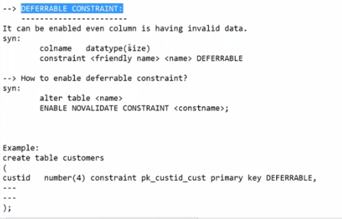

But for normal constraints (without differable keyword), we can not enable the constraints if the column already have invalid data.

If we add differable keyword then we can enable the constraints even the column consists of invalid data.

We can define any constraint as differable except NOT NULL constraint.

In some business data there may be a case where we can not apply constraints, there invalid data uploaded. Later we can apply constraints(differable).

If we want to maintain database from now onwards, we don’t want to accept the object invalid data. In that cases we can use differable.

SQL> --CREATING STUDENT TABLE WITH COLUMNS RNO, SNAME, MOBNO

SQL> CREATE TABLE STUDENT

2 (

3 RNO NUMBER(10) CONSTRAINT PK_RNO_STUDENT PRIMARY KEY DEFERRABLE,

4 SNAME VARCHAR2(10),

5 MOBNO NUMBER(10) CONSTRAINT UK_MOBNO_STUDENT UNIQUE

6 );

Table created.

SQL> --DISABLE PRIMARY KEY CONSTRAINT

SQL> ALTER TABLE STUDENT

2 DISABLE CONSTRAINT PK_RNO_STUDENT;

Table altered.

SQL> SELECT CONSTRAINT_NAME, CONSTRAINT_TYPE, STATUS FROM USER_CONSTRAINTS WHERE TABLE_NAME='STUDENT';

CONSTRAINT_NAME C STATUS

------------------------------ - --------

PK_RNO_STUDENT P DISABLED

UK_MOBNO_STUDENT U ENABLED

SQL> ALTER TABLE STUDENT

2 DISABLE CONSTRAINT UK_MOBNO_STUDENT;

Table altered.

SQL> SELECT CONSTRAINT_NAME, CONSTRAINT_TYPE, STATUS FROM USER_CONSTRAINTS WHERE TABLE_NAME='STUDENT';

CONSTRAINT_NAME C STATUS

------------------------------ - --------

PK_RNO_STUDENT P DISABLED

UK_MOBNO_STUDENT U DISABLED

SQL> --NOW INSERTING DATA WITH VALID AND INVALID VALUES.

SQL> DESC STUDENT

Name Null? Type

----------------------------------------- -------- ----------------------------

RNO NUMBER(10)

SNAME VARCHAR2(10)

MOBNO NUMBER(10)

SQL> INSERT INTO STUDENT VALUES(1, 'A', 9876543210);

1 row created.

SQL> INSERT INTO STUDENT VALUES(2, 'B', 9876543210);

1 row created.

SQL> INSERT INTO STUDENT VALUES(3, 'X', 9876543211);

1 row created.

SQL> --UPTO NOW RNO, SNAME ARE ONLY VALID VALUES BUT MOBNO IS INVALID AS IT CONTAINS DUPLICATE VALUES.

SQL> INSERT INTO STUDENT VALUES(1, 'C', 9876543212);

1 row created.

SQL> INSERT INTO STUDENT VALUES(NULL, 'Y', 9876543213);

1 row created.

SQL> SELECT * FROM STUDENT;

RNO SNAME MOBNO

---------- ---------- ----------

1 A 9876543210

2 B 9876543210

3 X 9876543211

1 C 9876543212

Y 9876543213

SQL> --WE HAVE NULL VALUE IN RNO, EVEN IT IS ACCEPTED.

SQL> --NOW ENABLING PRIMARY KEY ON RNO COLUMN

SQL> ALTER TABLE STUDENT

2 ENABLE NOVALIDATE CONSTRAINT PK_RNO_STUDENT;

Table altered.

SQL> ALTER TABLE STUDENT

2 ENABLE NOVALIDATE CONSTRAINT UK_MOBNO_STUDENT;

ALTER TABLE STUDENT

*

ERROR at line 1:

ORA-02299: cannot validate (SYSTEM.UK_MOBNO_STUDENT) - duplicate keys found

SQL> ALTER TABLE STUDENT

2 ENABLE CONSTRAINT UK_MOBNO_STUDENT;

ALTER TABLE STUDENT

*

ERROR at line 1:

ORA-02299: cannot validate (SYSTEM.UK_MOBNO_STUDENT) - duplicate keys found

SQL> -- IF WE OBSERVE ABOVE COMMANDS , WE CAN SEE CLEARLY. IT IS NOT POSSIBLE TO ENABLE NORMAL CONSTRAINTS.

SQL> -- DEFERRABLE CONSTRAINT DOES NOT VERIFY OLD DATA, SO WE ARE ABLE TO ENABLE.

SQL> ALTER TABLE STUDENT

2 ADD CONSTRAINT UK_MOBNO_STUDENT_DEFERRABLE UNIQUE DEFERRABLE;

ADD CONSTRAINT UK_MOBNO_STUDENT_DEFERRABLE UNIQUE DEFERRABLE

*

ERROR at line 2:

ORA-00906: missing left parenthesis

SQL> ED

Wrote file afiedt.buf

1 ALTER TABLE STUDENT

2* ADD CONSTRAINT UK_MOBNO_STUDENT_DEFERRABLE UNIQUE DEFERRABLE

SQL> --LETS CHANGE MOBNO TO VALID MOBNO THEN TRY TO ENABLE UNIQUE CONSTRAINT

SQL> SELECT CONSTRAINT_NAME, CONSTRAINT_TYPE, STATUS FROM USER_CONSTRAINTS WHERE TABLE_NAME='STUDENT';

CONSTRAINT_NAME C STATUS

------------------------------ - --------

PK_RNO_STUDENT P ENABLED

UK_MOBNO_STUDENT U DISABLED

SQL> DESC STUDENT;

Name Null? Type

----------------------------------------- -------- ----------------------------

RNO NUMBER(10)

SNAME VARCHAR2(10)

MOBNO NUMBER(10)

SQL> SELECT * FROM STUDENT;

RNO SNAME MOBNO

---------- ---------- ----------

1 A 9876543210

2 B 9876543210

3 X 9876543211

1 C 9876543212

Y 9876543213

SQL> UPDATE STUDENT SET MOBNO=9876543215 WHERE RNO=2;

1 row updated.

SQL> SELECT * FROM STUDENT;

RNO SNAME MOBNO

---------- ---------- ----------

1 A 9876543210

2 B 9876543215

3 X 9876543211

1 C 9876543212

Y 9876543213

SQL> ALTER TABLE STUDENT

2 ENABLE CONSTRAINT UK_MOBNO_STUDENT;

Table altered.

SQL> --YEAH , NOW WE ARE ABLE TO ENABLE. THIS IS EXAMPLE FOR NORMAL CONSTRAINT AND DEFERRABLE CONSTRAINT.

SQL> SELECT CONSTRAINT_NAME, CONSTRAINT_TYPE, STATUS FROM USER_CONSTRAINTS WHERE TABLE_NAME='STUDENT';

CONSTRAINT_NAME C STATUS

------------------------------ - --------

PK_RNO_STUDENT P ENABLED

UK_MOBNO_STUDENT U ENABLED

**SEQUENCES :**

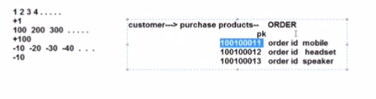

SEQUENCE IS USEFUL EVERY WHERE.

EX : TO INCREASE ORDER ID, PRODUCT ID, VEHICLE REG NUMBER AUTOMATICALLY.

WE CAN DEFINE STARTING VALUE OR DEFAULT VALUE IS 1.

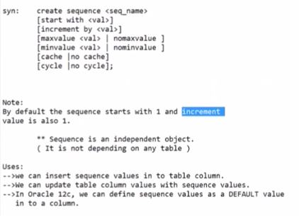

ALL ARE OPTIONAL (IF NOT MENTION, IT TAKES DEFAULT VALUE)

SEQUENCE IS NOT DEPENDING OBJECT.

IT IS NOT DEPENDING ON ANY TABLE.

BY SEEING THE SEQUENCE, WE CANT SAY THE SEQUENCE BELONG TO ANY TABLE OR NOT.

CAN BE IDENTIFIED FROM DOCUMENTS ONLY.

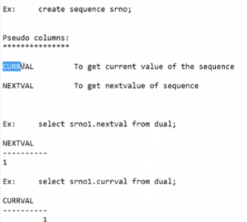

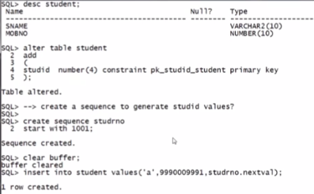

SQL> ALTER TABLE STUDENT

2 ADD

3 (

4 STUDID NUMBER(10)

5 );

Table altered.

SQL> SELECT * FROM STUDENT;

RNO SNAME MOBNO STUDID

---------- ---------- ---------- ----------

1 A 9876543210

2 B 9876543215

3 X 9876543211

1 C 9876543212

Y 9876543213

SQL> INSERT INTO STUDENT(STUDID) VALUES(SEQQ.NEXT) WHERE SNAME='A';

INSERT INTO STUDENT(STUDID) VALUES(SEQQ.NEXT) WHERE SNAME='A'

*

ERROR at line 1:

ORA-00933: SQL command not properly ended

SQL> UPDATE STUDENT SET STUDID=SEQQ.NEXT WHERE SNAME='A';

UPDATE STUDENT SET STUDID=SEQQ.NEXT WHERE SNAME='A'

*

ERROR at line 1:

ORA-00904: "SEQQ"."NEXT": invalid identifier

SQL> UPDATE STUDENT SET STUDID=SEQQ.NEXTVAL WHERE SNAME='A';

1 row updated.

SQL> UPDATE STUDENT SET STUDID=SEQQ.NEXTVAL WHERE SNAME='B';

1 row updated.

SQL> UPDATE STUDENT SET STUDID=SEQQ.NEXTVAL WHERE SNAME='X';

1 row updated.

SQL> UPDATE STUDENT SET STUDID=SEQQ.NEXTVAL WHERE SNAME='C';

1 row updated.

SQL> UPDATE STUDENT SET STUDID=SEQQ.NEXTVAL WHERE SNAME='Y';

1 row updated.

SQL> SELECT * FROM STUDENT;

RNO SNAME MOBNO STUDID

---------- ---------- ---------- ----------

1 A 9876543210 1001

2 B 9876543215 1002

3 X 9876543211 1003

1 C 9876543212 1004

Y 9876543213 1005

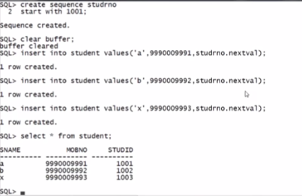

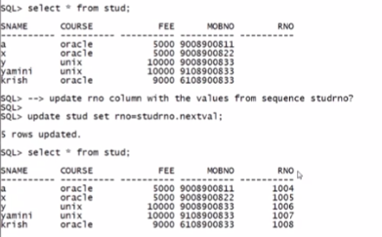

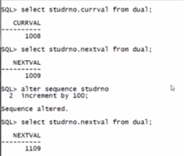

WE CAN CHANGE THE INCREMENT VALUE BY USING ABOVE PROCEDURE.

